Class 3

Variable initializing rules:

Globally declare:

Let create scope for group

Literals: variables rules are there (_,F,$)to create difference between variables and Literals

Single line comments for defining

Multiline

Difference between null and undefined types

Practice primitive data types

Rules of resolving errors ; do yourself

Primitive data types and Operators

Class 4:

1. Opening console in a browser f 12
2. Converts to Primitive data type

Focus and Practice,

Difference between Dependencies and Dev dependencies, Proper paragraph assignments

* Be 2 steps ahead
* Prompt Input nae chal raha
* > Prompt Scenario

# **Computer Programming - Environment**

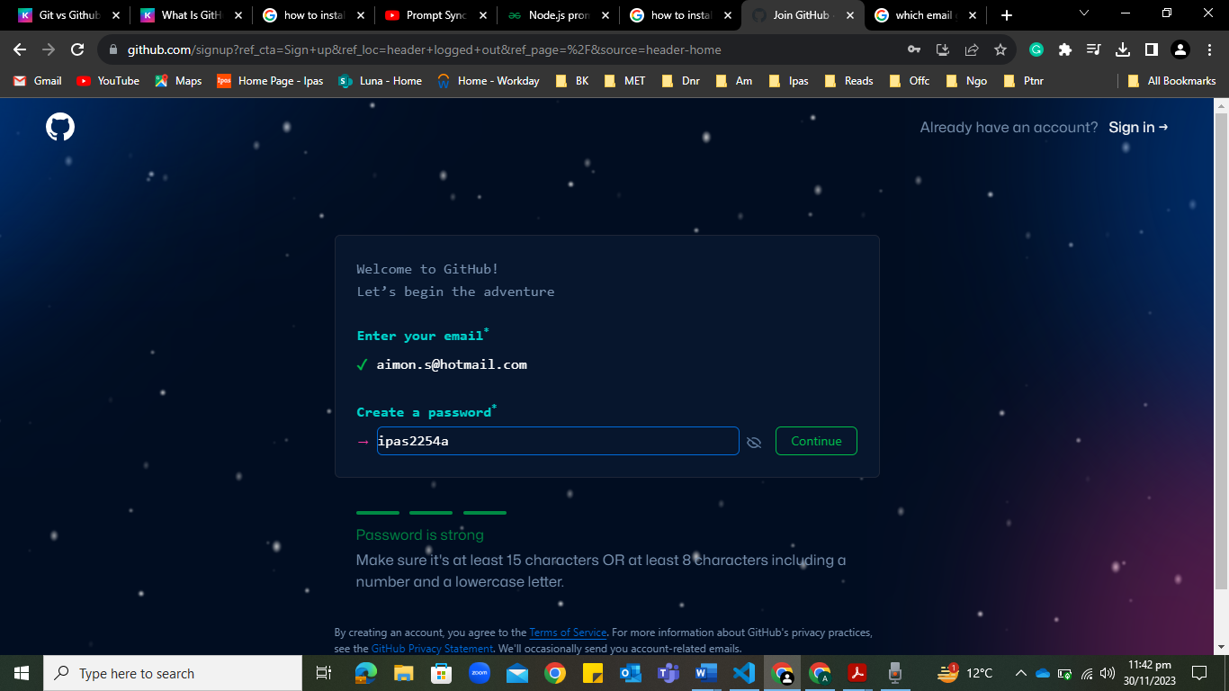



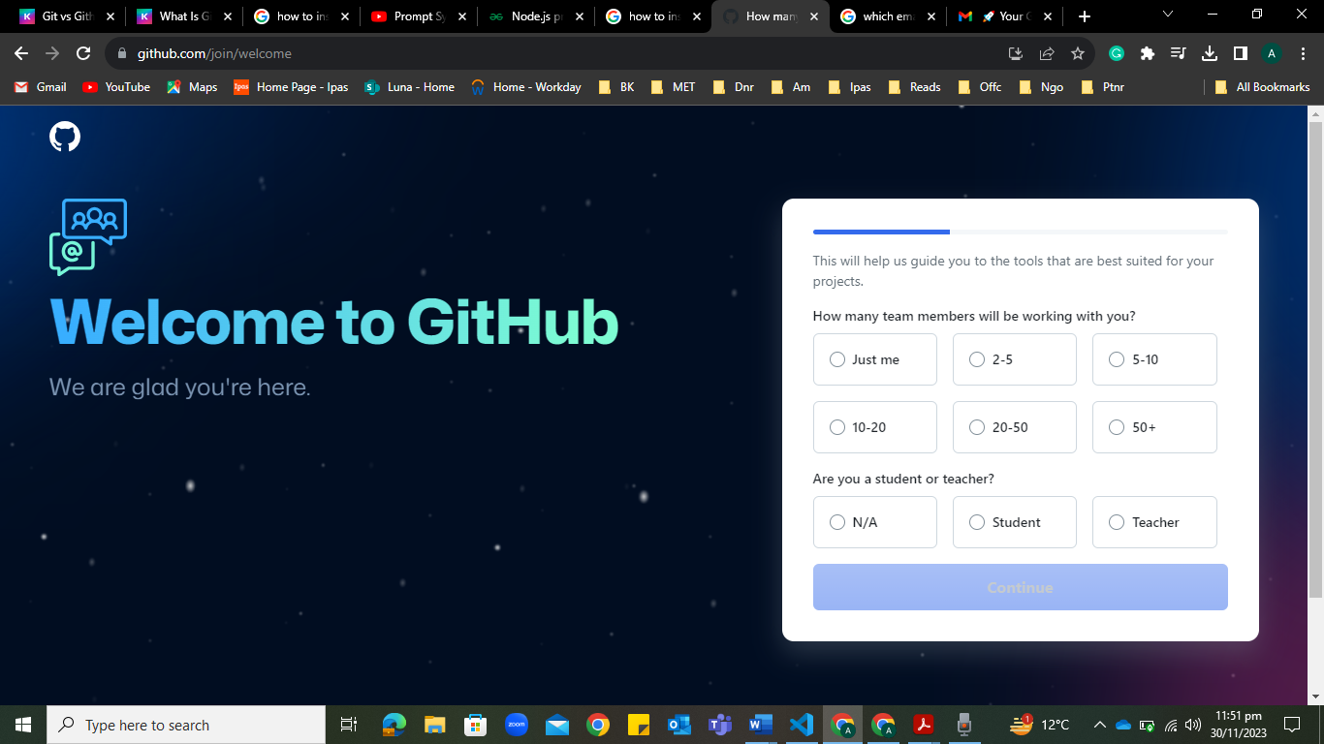

Things to do:

1. Linking git hub repo to git. Learn completely.
2. Do more and revisions of HTML & CSS
3. Typescript Basics; Environment Setup + Node JS + Project Setup

Operators, Functions, Decisions, Loops, Arrow functions, Arrays,

1. Understanding logic thinking and coding, to do all coding problems
2. Build a LinkedIn portfolio.
3. Presentation for entrepreneurship